MAY 2015 – UPDATED PROGRAM (08.05.2015)
 | Date | Time | Venue | Event / Topic | Intensive
1 | Fri 01 | 6.30-8pm | TS Lodge | Open Talk / Satsang, Q&A | ∞
2 | Sat 02 | 10am-1pm | TS Lodge | Personal Development Program - Pt.1 ‘Stress & Energy Management’
 |  | 6.00-8pm | TS Lodge | Open Talk / Satsang, Q&A | ∞
3 | Sun 03 |  |  | Vesak, Day off
4 | Mon 04 | 7.30-9pm | TS Lodge | Satsang Theatre | ∞
5 | Tue 05 | 9.30-11.30am | Yogshakti | Open Talk / Satsang, Q&A, guided meditation & self-inquiry | ∞
 |  | 7.30-9.30pm | TS Lodge | Open Talk / Satsang, Q&A, ‘Dealing with Death & Loss’
6 | Wed 06 | 7.30-9.30pm | TS Lodge | Personal Development Program-Pt.2, ‘Deep Relaxation’
7 | Thu 07 | 7.30-9pm | TS Lodge | Open Talk / Satsang, Q&A | ∞
8 | Fri 08 | 7.30-9pm | TS Lodge | Open Talk / Satsang, Q&A – ‘Mind, Ego, Suffering’ | ∞
9 | Sat 09 | 10am-1pm | TS Lodge | Personal Development Program -Pt.3, ‘Feelings & Needs (NVC)’
 |  | 6.00-8pm | TS Lodge | Satsang Party | ∞
10 | Sun 10 | 8am-6pm | Wanaka Bungalow | ‘One Day Silent Retreat’ – Discover your true nature, see detailed program | ∞
11 | Mon 11 | 7.30-9pm | TS Lodge | Satsang Music & Singing – bring your instruments | ∞
12 | Tue 12 | 9.30-11.30am | Yogshakti | Open Talk / Satsang, Q&A, guided meditation & self-inquiry | ∞
 |  | 8-10pm | Clive & Clove | Open Talk / Satsang, Q&A – ‘I AM THAT, Realizing our true nature’
13 | Wed 13 | 7.30-9.30pm | TS Lodge | Personal Development Program -Pt.4, ‘Loving the Inner Child’
14 | Thu 14 | 7pm |  | Private group | ∞
15 | Fri 15 | 7.30-9pm | CSA | Open Talk / Satsang, Q&A – Consciousness & I | ∞
16 | Sat 16 | 1.30-4.30 | Yogshakti | The Yoga of Knowledge – Talk/Satsang & Interactive Advaita Workshop
 |  | 6.00-8pm | TS Lodge | Open Talk / Satsang, Q&A | ∞
17 | Sun 17 | 10am-4pm | Yogshakti | ‘Self-Healing Workshop, Pt.1’ – ‘Dive In’ to the body-mind | ∞
18 | Mon 18
19 | Tue 19
20 | Wed 20
21 | Thu 21
22 | Fri 22 | 6am leave KL | Maranata Retreat | 3 Day Silent Advaita Self Awareness Retreat, see detailed program | ∞
23 | Sat 23 |  | House, Janda | 3 Day Silent Advaita Self Awareness Retreat
24 | Sun 24 | 7pm arrive KL | Baik | 3 Day Silent Advaita Self Awareness Retreat
25 | Mon 25 | 7.30-9.30pm | TS Lodge | Open Talk / Satsang, Q&A | ∞
Venues: |  | Address:
TS Lodge |  | Menara Mutiara Majestic, 7th Floor, Unit 707, Jalan Othman, PJ Old Town.
Clive & Clove |  | F-02-02, Jalan ss6/5b, Kelana Jaya, Petaling Jaya
‘Yogshakti’ |  | 23 Jalan Damai, Off Jalan Tun Razak, near Ampang Park LRT
CSA |  | Pure Life Society, Batu 6, Jalan Puchong
One on One: |  | Ragi is available for personal meetings and healing sessions on request, one and a half hours.
Synopsis of Events:
∞Talks / Satsang:
‘It is an invitation to realize your true nature as consciousness, and discover peace of mind.’
Spiritual Talks / Satsang are based on a question and answer format where people are invited to ask any questions they may have relating to their spiritual search or practice and share their own experience. The basic framework is from an Advaita / non duality perspective, and Ragi shares with seekers from his own experience and the teachings received from his Gurus. Participants can learn simple and direct meditation and self-inquiry techniques to experience the knowledge of their true nature.
∞One Day Retreat:
‘We can learn how to live daily life unencumbered by the incessant chattering of the mind.’
This is an opportunity to spend a day in silence in the city recharging and rejuvenating the mind and body. We can understand the mechanism of the mind, thoughts and thought patterns and be free of mental suffering. People will experience a variety of meditations and self-inquiry methods, energizing and grounding exercises, movement and laughter, and an opportunity to share their experience and questions in the discussion session.
(Please see detailed retreat Program)
∞3 Day Self Awareness Retreat:
‘Go deeper into yourself beyond thoughts and find the ever present stillness of your being.‘
Our true nature as Consciousness is always here and through allowing our-self to be in silence without the need to express our thoughts in words we can experience that deeper part of our being. Over the 3 days people will be able to deepen their practice of self-inquiry and meditation in a supportive peaceful environment at the Retreat Centre. Each day will offer exercises for the body to be energized and grounded, a practice of balancing the chakra energy points for emotional and psychological well-being, and time for deep relaxation and reflection. There will be a spiritual talk / satsang each day for people who feel the need to express themselves, where questions from the practices and what is being experienced can be shared. Retreaters are offered an opportunity to experience life without reading, writing, phones or talking. Simply watch what arises in the mind/body, and be completely comfortable with it, become aware of the impermanent illusory nature of things, and realize the permanent ever-present nature of your real being.
(Please see detailed Retreat Program)
∞Personal Development Program (PDP):
‘We are perfect, and in that perfection we can balance whatever aspect of our-self we want to’
The Personal Development Program (PDP) is a Six part workshop over 21 Days and includes; Stress & Energy Management, Deep Relaxation, Feelings & Needs (NVC), Dealing with Death & Loss, Loving our Inner Child, Living our Potential. It is designed for people from varying backgrounds and ages who want to live life in Peace, Joy and Harmony. The course involves balancing the mind / body organism using diverse techniques; meditations, visualizations, breathing, movement, stretching, sound, energy balance, understanding the mind, and the link in between thoughts, emotions, feelings and needs. We learn to listen to our needs and love ourselves unconditionally.

“You are the infinite Consciousness,
perfect in every way.
know that, and be at peace.”

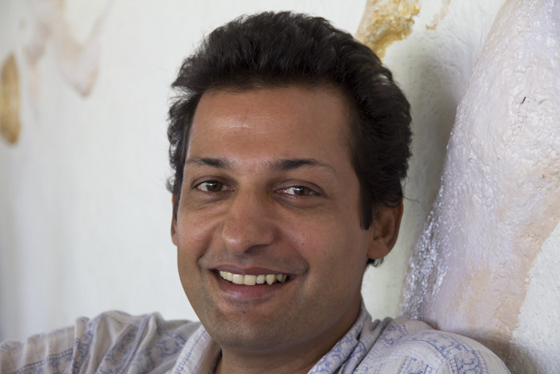

Background of Ragi
Ragi spent five years regularly visiting his Guru Ramesh Balsekar, who was a disciple of
Nisargadatta Maharaj, in his home in Bombay. He also draws on the teachings of Ramana Maharshi from Arunachala in Tiruvannamalai, were he lives part of the year. Ragi shares with spiritual seekers his own experience, and the teachings received from the Gurus. Over a ten year period he practiced with several meditation, yoga and energy healing teachers. He has been guiding meditation, self-awareness and personal development groups since 2005, and offering Advaita Talks, ‘Satsang’, over the last four years. Ragi also offers personal & organizational development coaching, and continues part time his former career as an architect.

For more information on the Advaita / Non Duality spiritual teachings, please visit:
Blog: RaghavanAdvaita.wordpress.com / www.RameshBalsekar.com

